**JUNIOR’S ZONE SCHOOL**

HALF-YEARLY EXAM (2017-18)

**SUB.: Science CLASS- VI**   **Max. Marks: 70**

**Section A**

**Tick the correct Options: [1 x 7 = 7]**

1. Which of the following is not a herbivore?
   1. Goat (b) Deer (c) Elephant (d) Tiger
2. Iron is a ______________

(a) vitamin (b) mineral (c) fat (d) energy

1. Which of the following is not a natural fibre?
   1. Nylon (b) Jute (c) Wool (d) Silk
2. What do we call the liquid that does not dissolve in water?
   1. Miscible (b) Immiscible (c) Pure (d) Impure
3. Veins are present in which part of the plant?
   1. Stems (b) Roots (c) Leaves (d) Seeds
4. Which one of the following has a tap root?
   1. Maize (b) Wheat (c) Neem (d) Rice
5. The height of a tower is 5.80 m. Its value in cm and will be –

(a) 580 (b) 5.8 (c) 58.0 (d) 0.58

**Section B**

1. Which part in this plant is modified to reduce the loss of water? **[ 1 ]**



1. Name the type of joint present in this bone. **[ 1 ]**



1. State any two conditions required for the formation of a shadow. **[ 1 ]**



1. What is A & B in this picture? **[ 1 ]**



12. Write any two special features of sparrow which helps it in easy movement. **[ 2 ]**

13. What is Transpiration? **[ 2 ]**

14. Differentiate between Conductors and Insulators .Give one example of each. **[ 3 ]**

15. Moon shines brightly in the night sky. Is it a Luminous or Non Luminous object? Give reason to justify your answer. **[3]**

16**.** What is happening to the X and Y muscles during the movement of the arm in the pictures shown here? Explain. **[ 4 ]**



17**.** (a) What is an electric circuit? **[ 5]**

(b) Write any two essential components of an electric circuit.

(c) Name any two sources from which we can obtain electricity.

18**.** Write an activity to prove that Light travels in a straight line. (Draw the diagrams also) **[ 5 ]**

***OR***

|  |  |
| --- | --- |
| Study the figure shown here and answer the related questions that follow:  (a) Name the device shown here  (b) What is the principle of working?  (c) Write any three characteristics of image formed in this device. |  |

19. Mention the type of change taking place in burning of candle and melting of candle. Also define these changes. **[ 3 ]**

20. (i) Identify the separating method shown in following figures. **[ 5 ]**

(ii) Explain these separation methods.

 

21. A doctor advised Roshan to take a 'balanced diet'. What do you think Roshan would take in his diet now? **[ 2 ]**

22. How is ginning useful in the making of fabrics from fibres? **[ 3 ]**

23. We separate components. Why do we need to separate different components of a mixture? Give examples to justify your answer. **[ 4 ]**

24. Draw a well labelled diagram of a flower and label it. **[ 5 ]**

25. Why do some materials float while other sinks in water? Explain. **[5 ]**

26. See the animals and write their habitation and features by which they are living. **[ 5 ]**

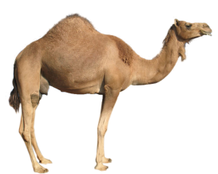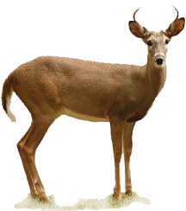

27. What was the need of standard units? **[3]**

**xxxxxxxxxxxxx**